
QUAKER QUILL
QUAKERTOWN BUSINESS& PROFESSIONALWOMEN’S CLUB
P.O. BOX 2, SPINNERSTOWN, PA 18968

STATE THEME: Running Through the Challenge with G.R.I.T.
(Growth, Resilience, Integrity, and Tenacity)
DISTRICT THEME: Faith. Gratitude. Service.
LOCAL THEME: Women Helping Community

www.bpwpa.wildapricot.org www.bpwfoundation.org www.BPWQuakertown.org
www.Facebookcom/QuakertownBusinessProfessionalWomenUpperBucks BPWQuakertown@gmail.com
OFFICERS 2025-2026
President – Melissa Wieand Corresponding Secretary-Gladys Benner
Vice-President – Diane Sodano Treasurer – Crystal Smith
Co-Recording Secretaries – Jeanne Schlicher & Parliamentarian – Toni Rubic
Nancy Werner
Volume 73 Issue 3 November, 2025

NOVEMBER MEETING:
Date: | November 19, 2025 (Note change in date from the Membership Handbook)
Place: | Brick Tavern Inn, 2460 Old Bethlehem Pike, Quakertown
 | 5:30 Networking, 5:45 Meeting, 6:00 Dinner, 7:00 Program
Program: | Dottie Dunn will introduce us to Angels Table, a woman-owned, non-profit organization that opened its doors in Quakertown in 2024 to provide a place of nourishment and encouragement for people of all economic levels, feeding and encouraging them, in an effort to create a more balanced community.
$35 Menu
Brick Tavern Burger (with or without cheese)
½ lb. Angus Burger, Grilled to Order, Served with Lettuce, Tomato and Onion on a Brioche Roll with French Fries or Homemade Coleslaw
Grilled, In-House Roasted Turkey Rachel
Swiss Cheese, Thousand Island Dressing and Coleslaw, Served on Marble Rye with French Fries or Homemade Coleslaw
The Brick Tavern Salad with or without Grilled Chicken (Shrimp add $5)
Crisp Romaine Lettuce, Tomato, Onion, Carrots, Cucumbers, Feta Cheese and Your Choice of Homemade Dressing
The Bethlehem Pike Salad (Shrimp add $5)
Baby Greens, Candied Walnuts, Sun-Dried Cranberries, Mandarin Oranges, and Danish Blue Cheese, tossed with Champagne Vinaigrette

$40 Menu
Blackened Chicken Penne Pasta
Served with Roasted Red Pepper and Mushroom Parmesan Cream Sauce
Beef Brisket
House-Smoked Brisket, Glazed with Brick Tavern Inn BBQ Sauce

$45 Menu
Blackened Salmon Florentine
Sauteed Spinach, Tomato, Roasted Red Pepper, White Wine Sauce

Coffee, tea and ice cream will be included with each meal. The $40/$45 meals come with your choice of soup or salad, chef’s accompaniments, rolls and butter.

RESERVATIONS OR CANCELLATIONS SHOULD BE MADE BY 4:00 pm on Wednesday, November 12, 2025. Call Crystal Smith at (267) 221-8978 or email her at smithcr@univest.net. PLEASE NOTE: after you reserve, if you are unable to attend the meeting, you are responsible for the meal payment.

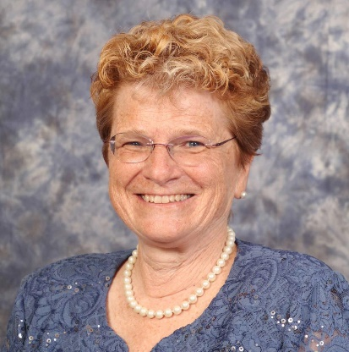
Holiday Greetings Ladies! We have a couple of events this month. On November 6th, we have members who will be traveling to Souderton to pack bags for the Bean Bag Food Program and on November 13th, Quakertown BPW will be hosting a membership drive at the Atrium, located on 5th street. I am also happy to announce, we have a new member, Dorothy Dunn, founder of Angels Table, who will be our November speaker! On December 10th, we will have our annual Holiday celebration with Upper Perk BPW. Congratulations, to member Rebecca Merola, on winning a seat on the Quakertown School Board. We are all very proud of Rebecca. At this very busy time of year, let us not forget to take a moment to count our many blessings. I am grateful to have you as my BPW sisters. Without every one of you, there would not be a Quakertown BPW. I look forward to sharing holiday joy with all of you, so please plan to join your BPW sisters during this special time of year for our holiday festivities. Thank you so much for all you do. .Peace and Joy, Missy
OCTOBER MEETING RECAP:

Our October meeting looked toward the Municipal Election coming up on November 4th. Vice President Diane Sodano explained the importance of voting in an election that lacks the “glamor” of a national contest but is actually more important to our day-to-day lives. She pointed out that in a Presidential election, our individual vote is 1 in 174 million votes! In a Mid-Term election (like next year) when we vote for our national representatives in the Senate (currently Sens. John Fetterman and David McCormick), our individual vote is 1 in almost 9 million, and for our national representatives in the House (currently Rep. Brian Fitzpatrick), our individual vote is 1 in 481,301! But in the Municipal Election electing candidates for our local governments (commissioners, supervisors, council or whatever your town calls it), our individual vote is 1 in hundreds … not thousands! This demonstrates how these local Municipal Elections are where your vote really counts! Member and candidate for the Quakertown Community School District School Board Rebecca Merola explained how important the school board is as these elected volunteers can levy taxes, decide policy, hire the school superintendent, and more. She encouraged everyone to learn what they can about the candidates for school board by checking out the League of Women Voters surveys and the individual candidate’s Facebook pages. While school board candidates do run as members of a political party, once elected they are expected to be nonpartisan. Follow-up Note: It appears the electorate has gotten the message about the importance of these Municipal Elections! 49.6% of Bucks County’s registered voters voted on November 4, 2025, vs. 40.8% in the Municipal Election of 2021! Keep up the good work!

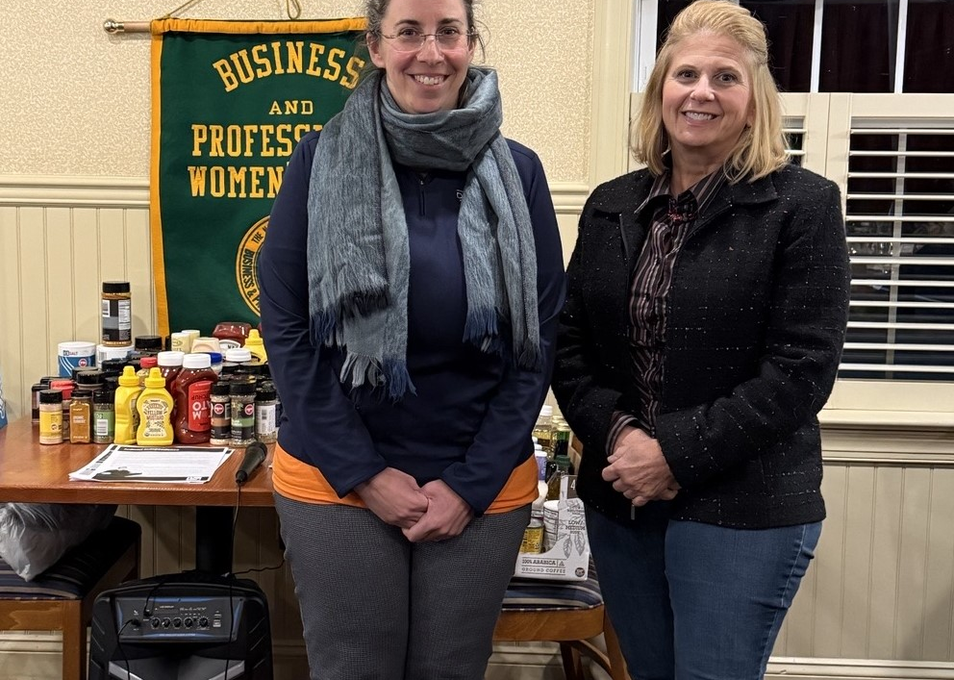
Member and School Board Candidate Rebecca Merola and V.P. Diane Sodano, who presented October’s program on the importance of voting in the November 4th Municipal Election.

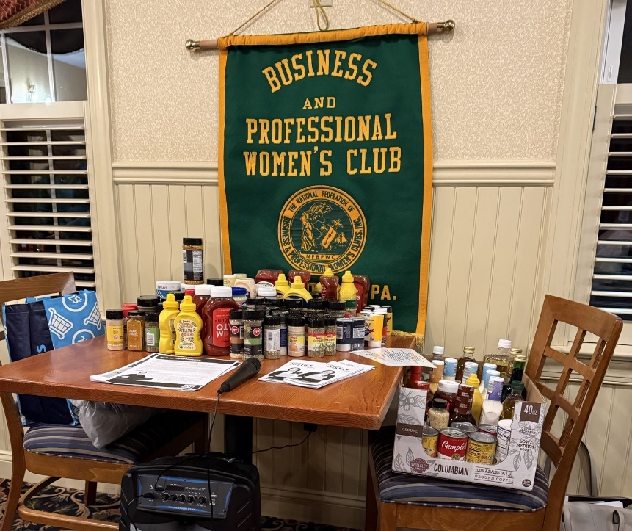

In addition, we collected the “little something extra” mentioned by Elizabeth Zbendin (our September speaker) for the Quakertown Food Pantry – an assortment of spices and condiments that supplement the usual groceries and make meals a little more interesting.

Membership
October 18th was a beautiful day for Quakertown’s Autumn Alive! We collected $205 and donated 41 of our “Turkey Dinner in a Bag” bags to the Quakertown Food Pantry. In addition, we met at least four local women who expressed an interest in possibly joining our group including Dottie Dunn of Angels Table and professional photographer Naomi O’Halloran, both of whom attended our October meeting! Everyone is reminded to bring friends and colleagues to our monthly meetings and to encourage them to join us! Help District 11 win this year’s Membership Contest – “Striding Towards Success.” And don’t forget to sign up for our Membership Drive event on Thursday, November 13th, 5:30 to 7:30 PM, at the Atrium. For details, see the flyer on page 6 of this newsletter.

Holiday Get-Together with Upper Perkiomen
Calling all trivia buffs! Our annual Holiday Party with Upper Perkiomen on Wednesday, December 10th, 5:30 to 8:30 PM, at the Gathering Place in downtown Quakertown, will feature a trivia expert! The meal will be catered by the Rupp Family Kitchen. The cost will be $40 per person. More details about the menu will be coming once dietary restrictions are determined. To RSVP, see the flyer on page 8 of this newsletter.

In the spirit of remembering holidays past, Toni Rubic (our Decorations Chair) is asking for 8 volunteers to share holiday centerpieces with special meaning for use at this year’s party. If you have a treasure left from your childhood or your children’s childhood, and would be willing to share (with the promise that all centerpieces will be returned unharmed), please contact Toni as soon as possible.

Food Pantry Donations
In keeping with our commitment to collect items needed by our local food pantries at our monthly meetings, we will be collecting beverages (coffee, tea, hot chocolate, juices) for the F.E.A.S.T. Pantry in Trumbauersville at our November meeting.

Senior Food Box Program
The Senior Food Box Program of the Bucks County Opportunity Council works to improve the health of low-income seniors by supplementing their diets with nutritious food. In Pennsylvania, eligible participants include low-income individuals who are at least 60 years old and whose household income is at or below 150 percent of the U.S. poverty level.

The senior food boxes do not provide a complete diet but rather are good sources of the nutrients typically lacking in the diets of older Americans. Among the types of foods included in the food boxes are non-fat dry and shelf-stable fluid milk, juice, oats, ready-to-eat cereal, rice, pasta, dry beans, peanut butter, canned meat, poultry, or fish, and canned fruits and vegetables.

The Senior Food Box Program is supported through USDA’s Commodity Supplemental Food Program. The USDA purchases the food and makes it available to the Department of Agriculture, which works with local non-profit agencies to facilitate distribution of the monthly food boxes to seniors in need at central locations where seniors have easy access. Currently, Trumbauersville’s F.E.A.S.T. Pantry has 17 seniors enrolled in the program. In October, due to recuperating from surgery, two of those seniors were unable to come to the Pantry to pick up their boxes and needed to have them delivered. Quakertown BPW provided that delivery service! It is unknown if there will be Senior Food Boxes in November or if the USDA will shut it down – like the SNAP program – until the government shutdown is resolved. But, if you wish to sign up to be part of the delivery program, please call Linda Moskal at 267-424-3768.

BPW/PA Legislative Committee Update

Good news first! PASB 507- Midwifery Modernization passed the PA Senate on October 21st! If you contacted your senator, give yourself a pat on the back. But there is still lots of work to do to protect female reproductive rights and safety.

HB1957- The Reproductive Rights Amendment protects the right to privacy for every individual with respect to personal, sexual and reproductive healthcare decisions. You can text, email or call your representative to say "I appreciate your support of the Reproductive Rights Amendment, HB 1957, because every person should have the right to bodily autonomy and to make the choice what health care is right for them without interference from laws passed in other states. Can I count on you to support this bill?"

HB2005- Removing the mandatory waiting period for abortion. This bill would remove the 24- hour waiting period to receive an abortion after mandatory counseling has been received. This waiting period demands that those seeking an abortion make multiple trips to a clinic, costing time and money and possibly increasing health safety concerns in cases where an abortion may be a life-saving procedure. Contact your representative to say, "Supporting HB2005 will allow women to receive the health care they need without a waiting period that may increase risks to their health. Please consider signing on as a cosponsor and please vote yes on HB2005."

Contacting your legislators does make a difference and we have seen movement on several bills that we supported. Remember our legislators work for us, but they can only help us if we let them know what we need!

Amanda L Collier, DC, State Legislative Committee Member

For the Good of the Order:
Corrections to the Membership Handbook: Please change Linda Lokay’s birthday to October 28.

Lottery Calendars are here and can be picked up at the November 19th meeting; $5.00 for two numbers as in years past. Remember, they make great holiday stocking stuffers! Winners will be determined in January 2026.


NOVEMBER BIRTHDAYS

Chrisine Fenn November 10
Gladys Benner November 19

DATES TO REMEMBER

11/06/25 “Bean Bag Program” Volunteer Opportunity
11/15/25 Greater Conshohocken BPW Vendor Fair
11/26/25 Quakertown’s General Meeting
11/27/25 HAPPY THANKSGIVING!
12/07/25 CMC BPW Annual Bingo Fundraiser
12/10/25 Annual Holiday Party with Upper Perk BPW
01/17/26 Personal & Professional Development Workshop (Upper Perk)

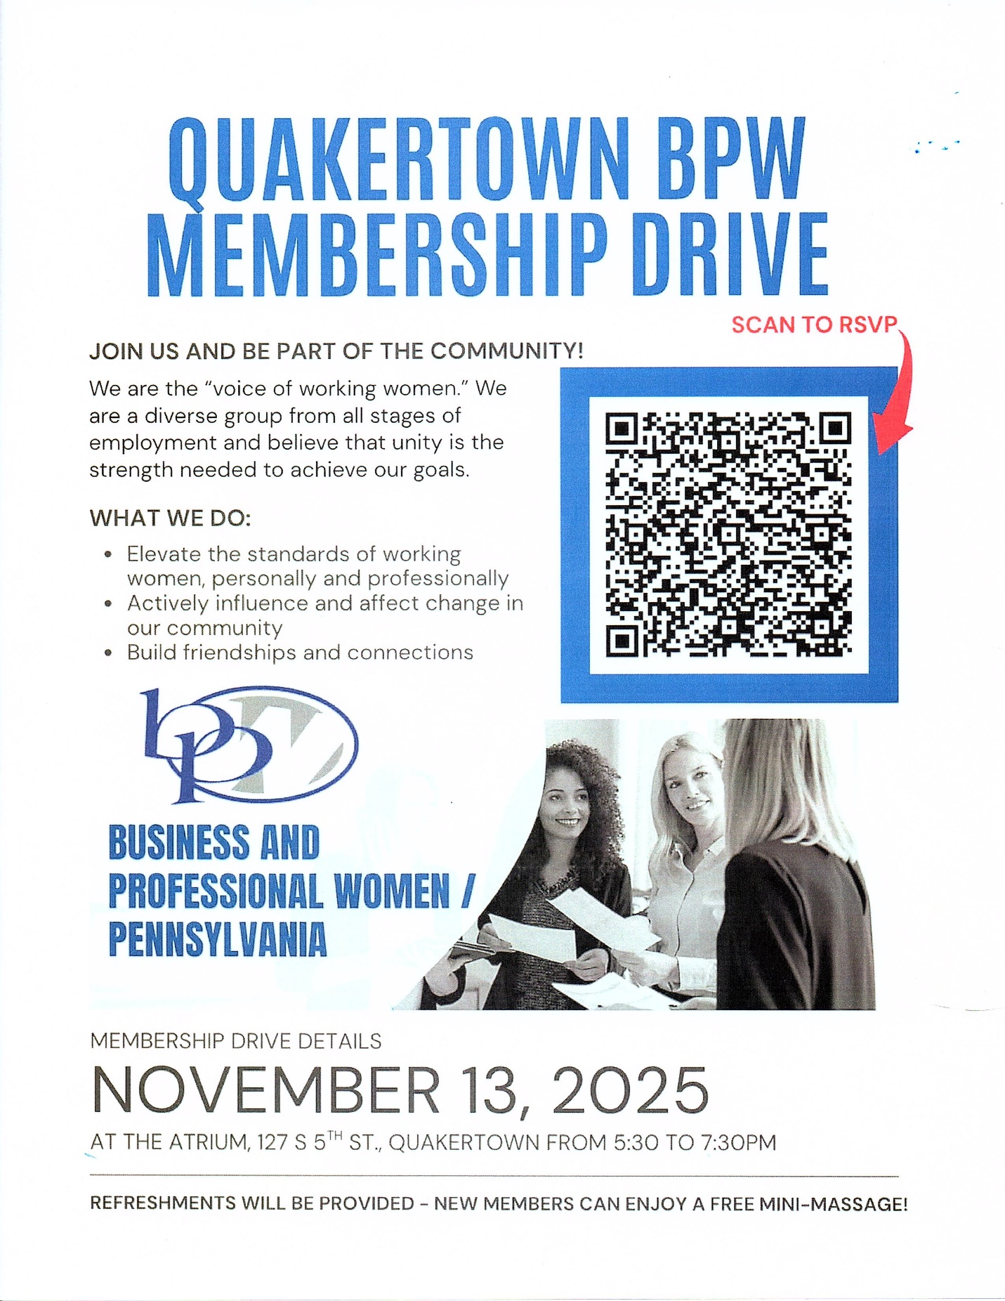

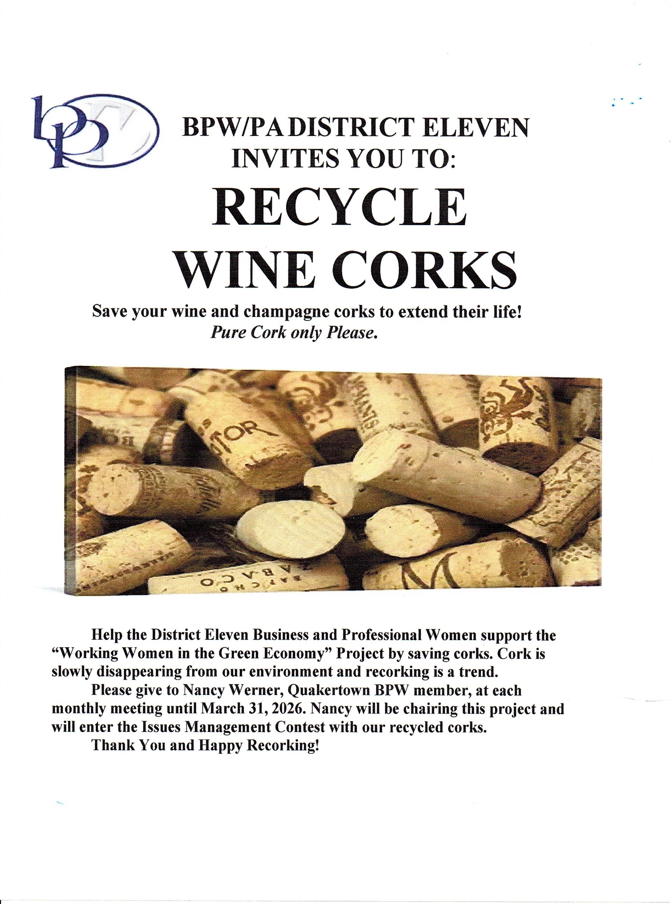

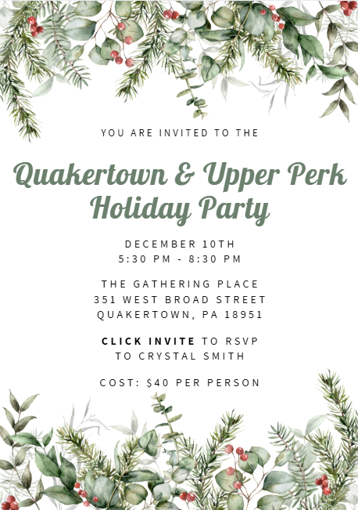

2025-2026 PATRONS
If you wish to include your business card in this year’s Quill, please email to linda.moskal@yahoo.com and remit $10 to Crystal Smith.

 | 
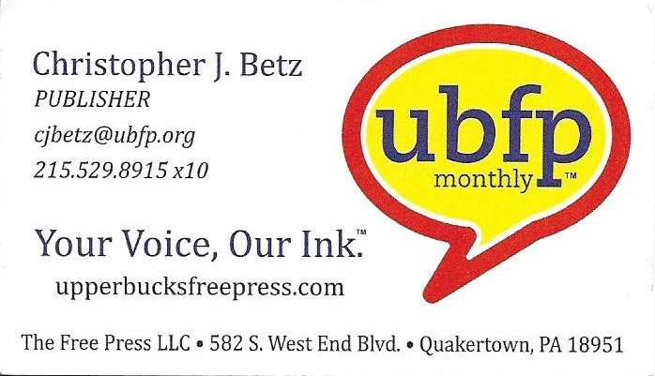 | 
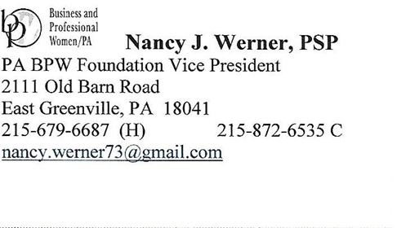 | 

