
QUAKER QUILL
QUAKERTOWN BUSINESS& PROFESSIONALWOMEN’S CLUB
P.O. BOX 2, SPINNERSTOWN, PA 18968

STATE THEME: Running Through the Challenge with G.R.I.T.
(Growth, Resilience, Integrity, and Tenacity)
DISTRICT THEME: Faith. Gratitude. Service.
LOCAL THEME: Women Helping Community

www.bpwpa.wildapricot.org www.bpwfoundation.org www.BPWQuakertown.org
www.Facebook.com/QtownBPWUB BPWQuakertown@gmail.com
OFFICERS 2025-2026
President – Melissa Wieand Corresponding Secretary-Gladys Benner
Vice-President – Diane Sodano Treasurer – Crystal Smith
Co-Recording Secretaries – Jeanne Schlicher & Parliamentarian – Toni Rubic
Nancy Werner
Volume 73 Issue 7 March, 2026

MARCH MEETING:
Date: | March 25, 2026
Place: | Brick Tavern Inn, 2460 Old Bethlehem Pike, Quakertown
 | 5:30 Networking, 5:45 Meeting, 6:00 Dinner, 7:00 Program
Program: | For National Women’s History Month our guest speaker will be Judge Ria Boylan, distinguished Senior Judge on the Bucks County Court of Common Pleas in Pennsylvania, recognized for her 20+ year tenure and leadership in establishing specialized treatment courts.
$35 Menu
Brick Tavern Burger (with or without cheese)
½ lb. Angus Burger, Grilled to Order, Served with Lettuce, Tomato and Onion on a Brioche Roll with French Fries or Homemade Coleslaw
Grilled, In-House Roasted Turkey Rachel
Swiss Cheese, Thousand Island Dressing and Coleslaw, Served on Marble Rye with French Fries or Homemade Coleslaw
The Brick Tavern Salad with or without Grilled Chicken (Shrimp add $5)
Crisp Romaine Lettuce, Tomato, Onion, Carrots, Cucumbers, Feta Cheese and Your Choice of Homemade Dressing
The Bethlehem Pike Salad (Shrimp add $5)
Baby Greens, Candied Walnuts, Sun-Dried Cranberries, Mandarin Oranges, and Danish Blue Cheese, tossed with Champagne Vinaigrette

$40 Menu
Blackened Chicken Penne Pasta
Served with Roasted Red Pepper and Mushroom Parmesan Cream Sauce
Beef Brisket
House-Smoked Brisket, Glazed with Brick Tavern Inn BBQ Sauce

$45 Menu
Blackened Salmon Florentine
Sauteed Spinach, Tomato, Roasted Red Pepper, White Wine Sauce

Coffee, tea and ice cream will be included with each meal. The $40/$45 meals come with your choice of soup or salad, chef’s accompaniments, rolls and butter.
RESERVATIONS OR CANCELLATIONS SHOULD BE MADE BY 4:00 pm on Wednesday, March 19, 2026. Call Crystal Smith at (267) 221-8978 or email her at smithcr@univest.net. PLEASE NOTE: after you reserve, if you are unable to attend the meeting, you are responsible for the meal payment.

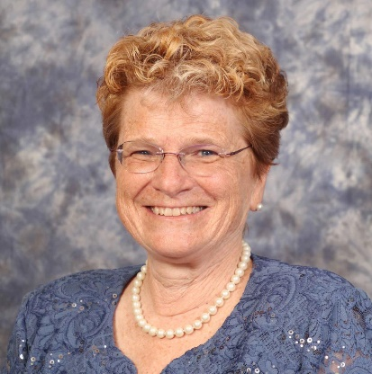
Happy “almost spring” ladies! March will bring excitement to our club. March is Women’s History month; to celebrate, we will have Retired Bucks County Judge Rea B Boylan as our speaker. We will also be celebrating our Rising Star winner. Be sure to attend our Unhappy Hour March 12th at the Trolley Barn. At our March meeting, we will be playing 2 rounds of paddle/quarter raffle in preparation for our 10th Annual event in April. I may not say it often, but I am very proud of the members of Quakertown BPW, both new and seasoned members. See you all at the March meeting. Warm Thoughts … Missy

FEBRUARY MEETING RECAP:
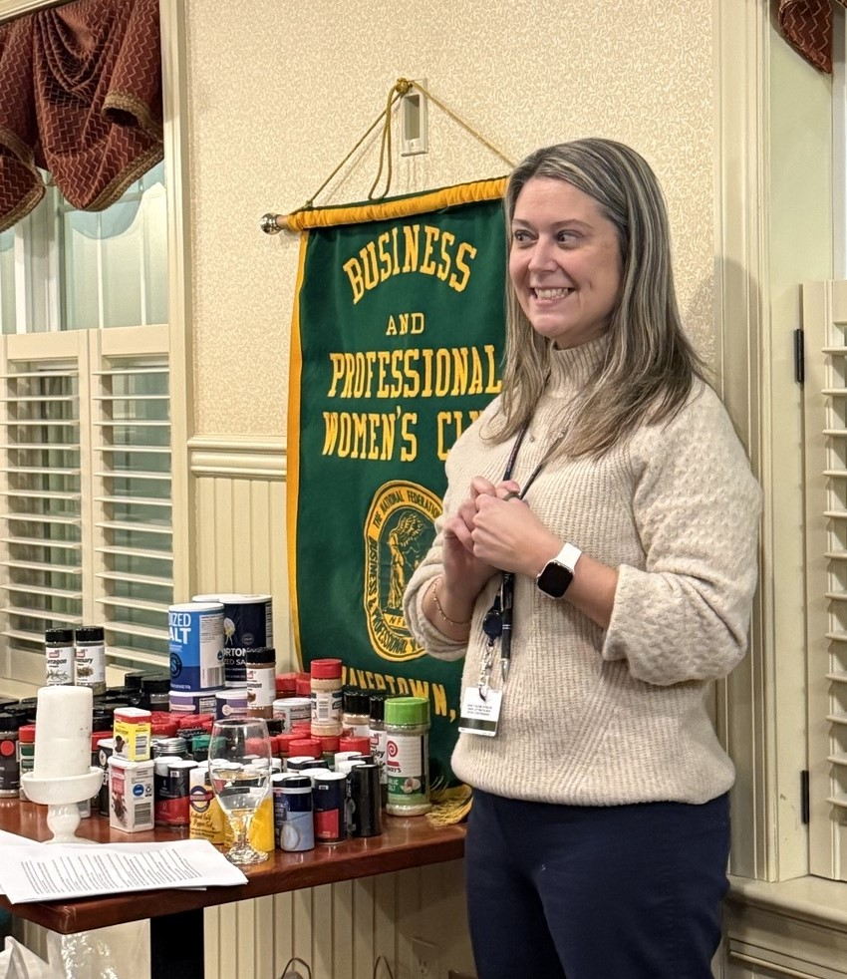
“Strong Hearts, Strong Women – Top 10 Heart Healthy Habits” presented by our own Crystalynn “Krissy” Mulligan, certified registered nurse practitioner in Cardiology, and lead APP at Penn Cardiology in Sellersville, was perfect for our recognition of National Heart Month! And while those 10 habits included maintaining strong social connections, regular aerobic exercise, no tobacco, controlling blood pressure, getting quality sleep, engaging in strength training, controlling LDL cholesterol, preventing diabetes, maintaining a healthy weight, and limiting alcohol consumption, they all seemed to lead back to Krissy’s #1 message: GO FOR A WALK!
In addition, we collected 35 pounds of salt, pepper and assorted spices including garlic, cinnamon, oregano, and more for FEAST Pantry in Trumbauersville. Over 80 containers!
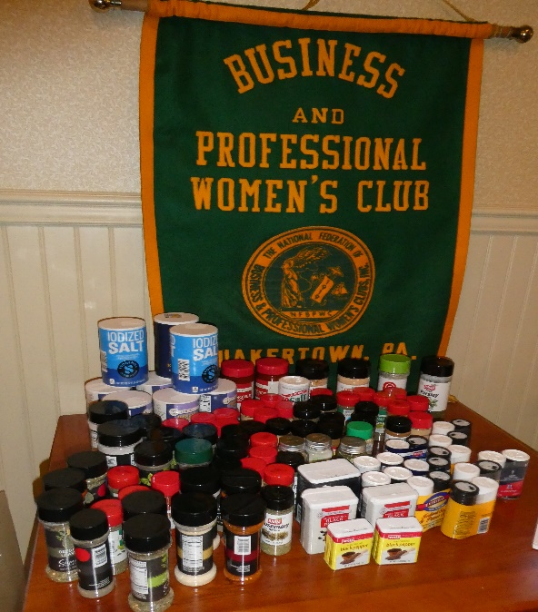

Membership
The February meeting saw District XI Director Sheryl Nierenberg induct three new members into Quakertown BPW. In this “official” induction photo is President Melissa Wieand, new member Cyndy Dumire, new member MaryFran Young, District XI Director Sheryl Nierenberg, and new member (and the night’s speaker) Crystalynn Mulligan.

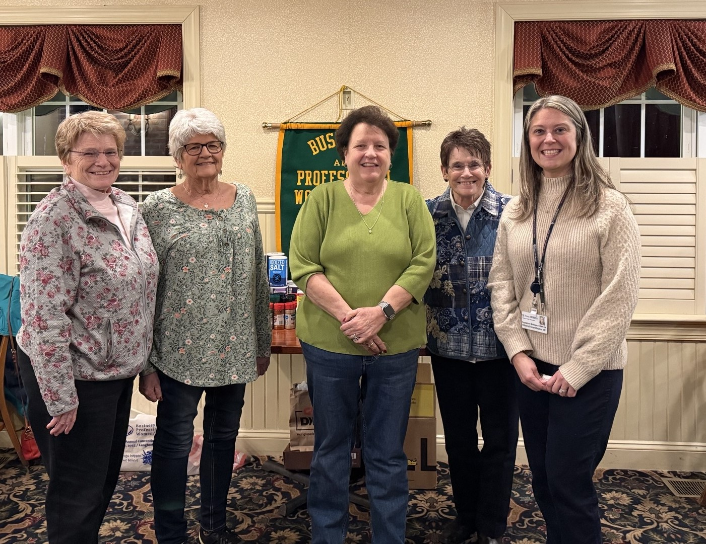

New General Meeting Location
With our club growing so quickly, it is time to consider finding a new location for our monthly meetings. Locations currently under consideration are Sunday’s on Front Street, a return to John’s Plain N Fancy, or the American Heritage meeting space next to The Designery on Route 309. Each has pluses and minuses. Make your opinion known by coming to the Board meeting on April 6 or by letting President Missy know (in writing, please). If you have another suggestion, that is requested, too.

Call to District XI Spring Meeting
District XI Corresponding Secretary Ginny Bailey has issued the call to Spring District Meeting for Saturday, April 11, 2026, at the Montgomery Township Community & Recreation Center, Horsham Road, Montgomeryville. All members are invited to attend. The cost is $20 and includes breakfast. Items on the agenda include an update on Distrct Bylaws from District Bylaws Chair Mo Gillen and the installation of District officers for the 2026-2027 year. If you wish to attend, please let President Missy know and send your $20 to Treasurer Crystal Smith. Deadline for registering is March 30, 2026.

Legislative Committee Update
“Equal Pay Day” is coming! “Equal Pay Day” is an attempt to raise awareness about the raw wage gap, the figure that shows that women, on average, earn about 80 cents for every dollar men earn, so that women must work well into the new year to earn what men did through December 31st! “Equal Pay Day” was originated by the National Committee on Pay Equity (NCPE) in 1996 as a public awareness event to illustrate the gap between men's and women's wages. The wage gap is even greater for most women of color. The “official” date for “Equal Pay Day 2026” is March 12th, but BPW/PA will observe it on Tuesday, March 24th, with a 1 PM rally with our legislators at the Capitol Rotunda in Harrisburg. If you cannot attend the rally, you can still observe “National Equal Pay Day” by increasing transparency about the issue. A good place to start would be at our “UnHappy Hour” at the Trolley Barn, 116 East Broad Street, Quakertown, on Thursday, March 12th. See the flyer on page 6.

PA BPW Foundation
It’s not too late to make your donation to the PA BPW Foundation. Please use the form on page 8 to make your donation and send your check to Crystal Smith by April 20, 2026, so that Quakertown BPW gets accurate credit for all donations at this year’s State Convention. If you have any questions, please ask Nancy Werner.

For the Good of the Order
President Missy Wieand distributed printed copies of the 2025-2026 Membership Handbook. Please make a correction on page 12: Dottie Dunn’s birthday is November 22.

Reminder that the Memorial Service for Shirley Andres who died on December 30, 2025, will be held on Friday, March 27, 2026, at Trinity Lutheran Church, 102 N. Hellertown Avenue, Quakertown, with visitation at 10 AM followed by the service at 11 AM. The family has requested donations to Feed the Children, P.O. Box 36, Oklahoma City, OK 73101-0036, to to Trinity Lutheran Church, in lieu of flowers. Shirley’s full obituary is available at the C.R. Strunk Funeral Home website (www.crstrunk.com).


MARCH BIRTHDAYS

Gail Jancsics March 05
Melissa Wieand March 07
Crystalynn Mulligan March 11

DATES TO REMEMBER
03/12/26 “UnHappy Hour” at Trolley Barn 5:30-7:30 PM
03/24/26 Equal Pay Day Rally, 1 PM, Harrisburg Capitol Rotunda
03/25/26 Women’s History Month – speaker Senior Judge Rea B. Boylan
04/06/26 Board of Directors Meeting – all invited
04/19/26 10th Annual Paddle Raffle, Benner Hall, Richlandtown
04/22/26 Speaker – Chief Barbara Blue Jay Michalski, Keeper of the Culture
of the Lenape Nation of Pennsylvania

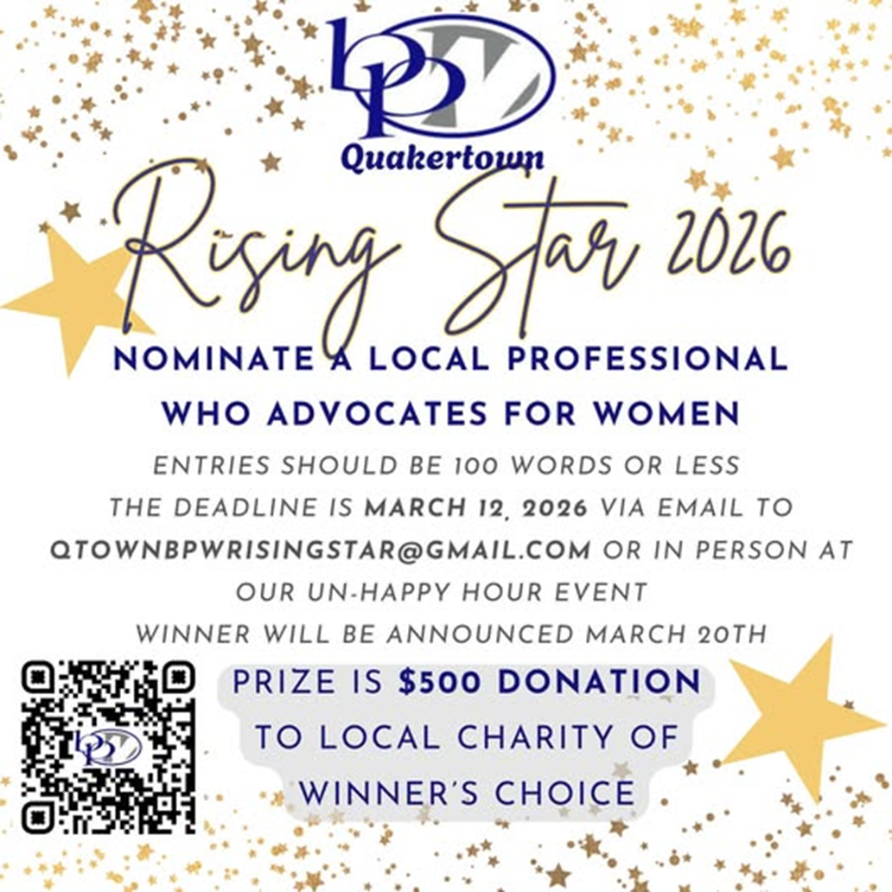




BPW/PA DISTRICT ELEVEN

GOT RECYCLEABLE
WINE CORKS?
\



AN UPDATE! Nancy Werner would love to have any and all your corks by the Spring District Meeting on Saturday, April 11, 2026. Please ask all your members for whatever they may have and bring to your monthly March meeting. Just one way to support the “Women in the Green Economy Project.” Many thanks.

2025-2026 PATRONS
If you wish to include your business card in this year’s Quill, please email to linda.moskal@yahoo.com and remit $10 to Crystal Smith.

 | 
 | 
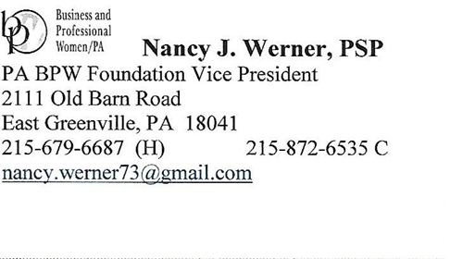 | 

