QUAKER QUILL
QUAKERTOWN BUSINESS& PROFESSIONALWOMEN’S CLUB
P.O. BOX 2, SPINNERSTOWN, PA 18968

STATE THEME: Grow Through What You Go Through
DISTRICT THEME: Count Your Blessings

www.bpwpa.wildapricot.org www.bpwfoundation.org www.BPWQuakertown.org
www.facebookcom/bpwquakertown BPWQuakertown@gmail.com

OFFICERS 2023-2024
Co-Presidents – Linda Moskal & Jeanne Schlicher Corresponding Secretary – Gladys Benner
Vice-President – Diane Sodano Treasurer – Crystal Smith
Recording Secretary – Nancy Werner Parliamentarian – Toni Rubic
Volume 71 Issue 7 March, 2024

MARCH MEETING
Date: | March 27, 2024
Place: | John’s Plain & Fancy Diner, 50 S. West End Blvd., Quakertown
 | 5:00 Networking, 5:30 Business Meeting, 6:00 Dinner, 7:00 Program
Menu: | Notify Cathy Somich of entrée choice, below.
Roasted Turkey with Mashed Potatoes - $35
Fried Haddock with Coleslaw - $35
Roasted Half Chicken with Broccoli - $35
Baked Virginia Ham with Broccoli - $35
Roast Beef with Mashed Potatoes - $35
Rib Eye Steak with French Fries - $40

Each entrée comes with a side salad, soup, as well as dessert choice of carrot cake or cheesecake. Soup, salad and dessert will be chosen at the meal. Meal cost includes soft drinks, iced tea and coffee/tea.
Program: | Discussion on our first Rising Star Campaign and what we’ve learned if we do it again.

For reservations: Call Cathy Somich at 215-536-8526 or email her at gcsomich@yahoo.com. Cell (267) 342-6200 for text msg. only. You will be telling Cathy only what entrée choice you would like. RESERVATIONS OR CANCELLATIONS SHOULD BE MADE NO LATER THAN 8:00 pm on Sunday, March 24. 2024. PLEASE NOTE: after you reserve if you are unable to attend the meeting, you are responsible for the meal payment.

CO-PRESIDENT’S MESSAGE

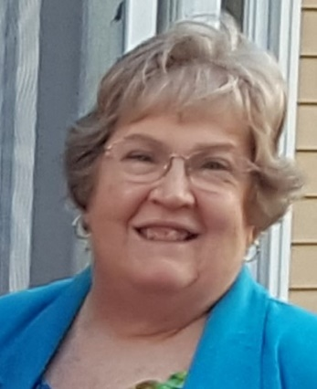
Ladies,
Welcome to March, a very important month in women's lives. It marks the time when the average working woman has finally reached the level of pay that a man had earned by December 31st! We have been marking this "Equal Pay Day" for too many years. We've had promises of legislation to require equal pay for equal work, but it has still not become a reality! I hope you all will come out to the "Un-Happy Hour" on Thursday, March 14th, from 6 to 8 PM, at the Trolley Barn in Quakertown to help raise awareness of this continuing situation. And, please, remember to wear red.

I hope you will also join BPW/PA for the "Pay Day" rally at the State Capitol in Harrisburg on Tuesday, March 26th, from 1 to 2 PM. A number of our elected officials will be there to support our efforts to make equal pay for equal work a reality.

And, of course, be sure to attend our March 27th General Membership meeting when we will learn the results of our first "Rising Star" promotion. Jeanne Schlicher, Crystal Smith, and Diane Sodano have done an awesome job in creating this new initiative.

Linda Moskal, Co-President

NEW MEMBERS
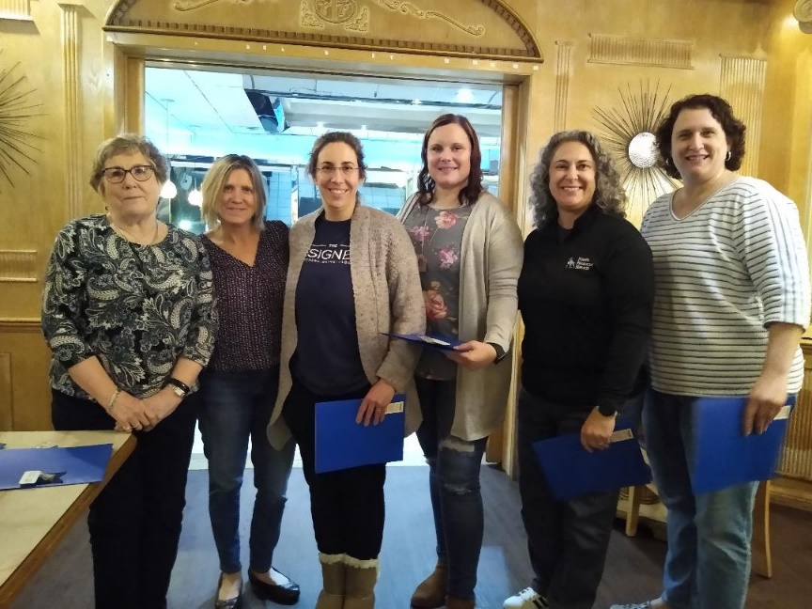

We welcomed five new members at the February meeting. From left to right are Pat Mullen, who installed them, Shelby Leight, Rebecca Merola, Christa Mann, Nicole Pompa and Brandy Neifert. So glad to have you join us in our endeavors!

WINTER BOARD MEETING
The BPW/PA Winter Board Meeting was held on March 1 and 2 in State College. Past State President, Nancy Werner, Immediate Past State President, Melissa Wieand and District Director Sheryl Nierenberg attended.

DONATIONS TO FOOD PANTRY

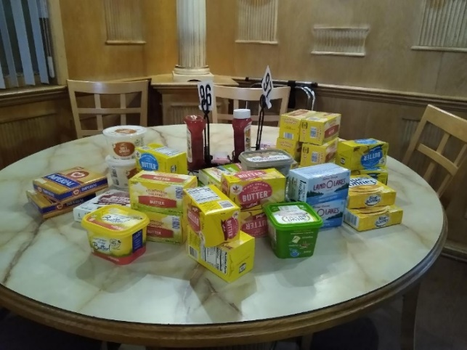

Butter and margarine spreads collected at the February meeting that was donated to the Quakertown Food Pantry.

The Board has selected sliced bread products for our March donation. Please bring them with you to our meeting on the 27th.

BPW/PA FOUNDATION
Nancy Werner, PA BPW Foundation Chair and a member, wishes to thank everyone who helped play BINGO last month. Your enthusiasm to learn about the PA BPW Foundation was empowering. Please remember a donation will go a long way as we sponsor scholarships and assist our members in need. Attached to the Quill is the form needed if you wish to make a donation. Thank you.

EQUAL RIGHTS AMENDMENT WEBINAR
The BPW/PA Legislative Committee is having a webinar on the Equal Rights Amendment on Thursday, March 21 at 7:00 p.m. Nancy Werner will share a travelogue to the Centennial ERA held last July 21 and 22 in Seneca Falls and will provide updates on what has happened during the last 7 months with the ERA. Please log onto the bpwpa.org and click the message to register. Make sure you get a response for your registration.

EQUAL PAY DAY RALLY
The Rally is held at the PA State Capitol Building on Tuesday, March 26, from 1:00 to 2:00 p.m. If interested in going, please contact Linda Moskal.

PADDLE RAFFLE
Melissa Wieand has tickets available for you to sell to friends and family to attend our Paddle Raffle on Sunday, April 28 at Benner Hall in Richlandtown. Cost is $10 which entitles you to one paddle and an entry into a door prize raffle. Members do not need to purchase a ticket. They are for the public. Doors open at noon. Any donations received from local businesses should be taken to Missy’s by April 21. At our meeting in March, Missy will be circulating a form for volunteer sign-ups. We will need all members to help.

BPW/PA DISTRICT 11 GET TOGETHER TEA
Ginny Bailey has arranged for our District 11 Tea at The Village Teahouse in West Point, PA (Lansdale). Time is 12:15 p.m. If you are still thinking of attending, let Ginny know before April 13. Cost will be $43, which includes tax and tip. At this point, Ginny is asking you to bring you cash with you to the tea instead of sending it to her. Ginny’s email is muffygin@aol.com.

BPW/PA DISTRICT 11 SPRING MEETING
The Spring District 11 Meeting will be held April 13th at Montgomery Township Community & Recreation Center, Montgomeryville. Greater Conshohocken BPW is hosting. Registration begins at 8:00, breakfast at 8:15 to 9:00 a.m. with the meeting beginning at 9:00. Cost of breakfast and registration is $20. Anyone may attend from Quakertown. Just let Linda Moskal know if you would like to attend, and see that Crystal Smith gets your cash or check. Checks should be made out to Quakertown BPW, as she will write one check for all LO members attending. Deadline is Saturday, April 6.

GREATER CONSHOHOCKEN BPW will be celebrating its 75th Anniversary on Saturday, March 23, 2024 from 12 noon to 3:00 p.m. at Phil’s Tavern in Blue Bell. Cost is $33 with a cash bar. If interested in attending, contact Donna Jones at conshohockenbpw@gmail.com. Nancy Werner from Quakertown will be attending so you may be able to carpool with her.

PA STATE CONVENTION
State Convention is planned for June 6-9 at the Best Western Premier in Harrisburg. It’ll be a fun-filled three days, and you learn lots about our organization. The forms for registration and information are on our website bpwpa.wildapricot.org. in the Members Only section. There is a bit of a cost savings if you register before March 31.

March Birthdays

Gail Jancsics 3/5
Melissa Wieand 3/7

UPCOMING DATES TO REMEMBER
March 21 Update on Equal Rights Amendment Webinar
March 23 Greater Conshohocken 75th Anniversary Celebration
March 26 Equal Pay Day Rally in Harrisburg
March 27 Quakertown General Meeting
April 1 Quakertown Board Meeting @ 6:30 p.m.
April 13 District 11 Spring Board Meeting in Montgomeryville
April 27 District 11 Tea at The Village Teahouse in West Point, PA
April 28 Paddle Raffle
May 4 Souderton-Telford’s 7th Annual Locally Grown Showcase
June 6-9 BPW/PA State Convention

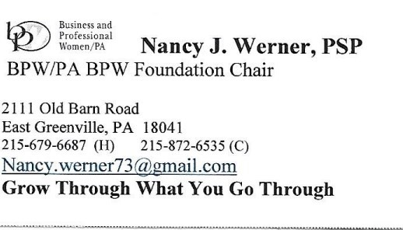 | 