
QUAKER QUILL
QUAKERTOWN BUSINESS& PROFESSIONALWOMEN’S CLUB
P.O. BOX 2, SPINNERSTOWN, PA 18968

STATE THEME: Dream Big and Squeeze the Day
DISTRICT THEME: Faith. Gratitude. Service.
LOCAL THEME:

www.bpwpa.wildapricot.org www.bpwfoundation.org www.BPWQuakertown.org
www.facebookcom/bpwquakertown BPWQuakertown@gmail.com

OFFICERS 2026-2027
President –Crystal Smith Corresponding Secretary – Gladys Benner
Vice-President –Diane Sodano Treasurer – Nicole Pompa
Recording Secretaries –Ellen Miron& Jeanne Schlicher Parliamentarian – Toni Rubic

Volume 74 Issue 2 September 2026

PRESIDENT’S MESSAGE:
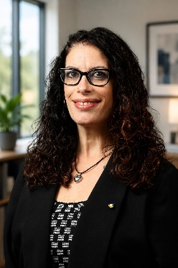
First, I cannot believe that September is here already, the summer went by so quickly, too quickly. However, I am very excited about our upcoming year! Our planning/board meeting, while overwhelming, was successful and with the state theme Dream Big, and Squeeze the Day, I hope you will Dream Big with me this year! I have a lot to learn as President, and I am grateful for the opportunity the club has given me to serve in this capacity. We will be participating in Autumn Alive on October 17th and I hope you will join me as we raise money for our State Project “Alex’s Lemonade Stand Foundation”, and making some community connections throughout the day. In the meantime, Squeeze the Day, President Crystal

NEXT MEETING
Our next meeting will be on Wednesday, September 23, 2026, with Networking beginning at 5:30 PM, Dinner at 6 PM, and at 7 PM, our Program “Back to Business,” a review of club basics including how to conduct a meeting using Parliamentary Procedure according to Robert’s Rules of Order. Reservations to be placed with President Crystal Smith by calling 267-221-8978 or emailing smithcr@univest.net no later than 4 PM on Tuesday, September 15th. There will be a $5.00 per person meeting fee to be paid in cash or check payable to Quakertown BPW to Treasurer Nicole Pompa.

New Location: John’s Plain & Fancy Diner, 50 South West End Boulevard (Route 309), Quakertown.

New Meal Procedure: Each person will order their meal off of John’s regular menu and will be responsible for paying their bill to the restaurant and providing their tip for the wait staff. A flat fee of $5.00 per person will be paid to Treasurer Nicole Pompa to go into the fund to pay for our guests’ meals.

QUAKERTOWN BPW MEETING SCHEDULE FOR 2026-2027:
Board Meetings will be held at 6:30 PM at The Designery, 280 North West End Boulevard (Route 309), Quakertown (unless otherwise noted) on:
September 2 February 3 via Zoom
October 7 March 3 via Zoom
November 4 April 7
January 6 via Zoom May 5

General Membership Meetings at John’s Plain & Fancy (unless otherwise noted) on:
September 23 February 24
October 28 March 24
November 18 April 28
December DTBD, LTBD May 26
January 27 June 23 LTBD

BOARD ACTIONS
The Board approved making a $300 donation to the Culinary Program at the Upper Bucks Vo-Tech for their participation in this year’s “Cook Around the World” competition, April 22-25, 2027, at Walt Disney World/EPCOT, where last year’s 10-student team placed 2nd in the “Entrée” category. This action will be presented at the September Meeting for membership ratification.

LOCAL PROJECTS
Autumn Alive (Saturday, October 17th 10 AM – 4 PM; raindate October 24)
Quakertown BPW will have a table and tent at this year’s Autumn Alive in downtown Quakertown where we will sell wooden cut-outs of lemonade-themed items for children (or adults) to paint at the Children’s Courtyard being sponsored by our members Rebecca Merola of The Designery and Nicole Pompa of Pompa Financial Services. A sign-up sheet for volunteers to work at our table will be circulated at the September meeting.

National Business Women’s Week (October 18-24, 2026)
We will once again be placing lawn signs in strategic places in our community announcing National Business Women’s Week. If you have a space in your yard or business that would be “perfect” for one (or more) of these signs, pick them up at the September meeting. Nancy Werner will again be sending editorials to our local newspapers. If you see them anywhere, please pick up a copy for our files! There are a number of other ideas for ways to celebrate the week floating around. They will be discussed further at the September meeting.

DISTRICT 11

WOMEN IN THE GREEN ECONOMY PROJECT
Nancy Werner will be heading up this year’s project for “Women in the Green Economy” for District 11. We will be collecting those medication vials that seem to accumulate so rapidly in our homes these days! It’s a great way to move them from your house to someone who can really use them instead of to a landfill somewhere. See the official flyer on page 6.

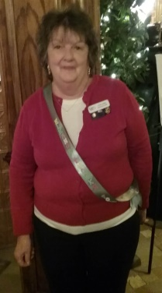
ELEANOR KNOKE FORMS
This photo of our “Eleanor Knoke Police Patrolwoman” Linda Lokay, in full dress, may be a picture from our past but our winning of the Eleanor Knoke Award is not! Linda will be checking on you for your current recorded hours for this project, so make sure you complete the form on page 5 of this newsletter.

BPW/PA
Our own Nancy Werner has accepted the position as Chair of the BPW/PA Legislative Committee. She and her committee have a lot of things planned for the 2026-2027 year so I see my role as Quakertown Legislative Chair as more of a supportive one so you may be hearing more from her than me this year. She is starting out with a number of Zoom meetings including one on September 29th, “Women’s Voting Rights,” shared by Lilly Gioia, District 8 Legislative Chair. Watch the Buzz for details on signing up for this Zoom meeting.

DATES TO REMEMBER

September 29 BPW/PA Legislative Zoom – “Women’s Voting Rights”
October 7 Quakertown Board Meeting
October 17 Autumn Alive – Alex’s Lemonade Stand fundraiser
October 24 District 11 Fall Meeting
October 28 Membership Meeting - District 11 Director’s official visit



SEPTEMBER
29 – Crystal Smith
30 – Cathy Somich
30 – Judy Guise

LOCAL MEMBER NEWS

NEW MEMBER INDUCTION
We will be inducting our new member, Debbie Nace at the September meeting. Please welcome her to our meeting.

Many of you remember Judy Guise’s flower displays at her home on Juniper Street. Her prowess has not waned since moving to Elizabethtown. This photo shows her winning entries in the Elizabethtown Fair this summer!

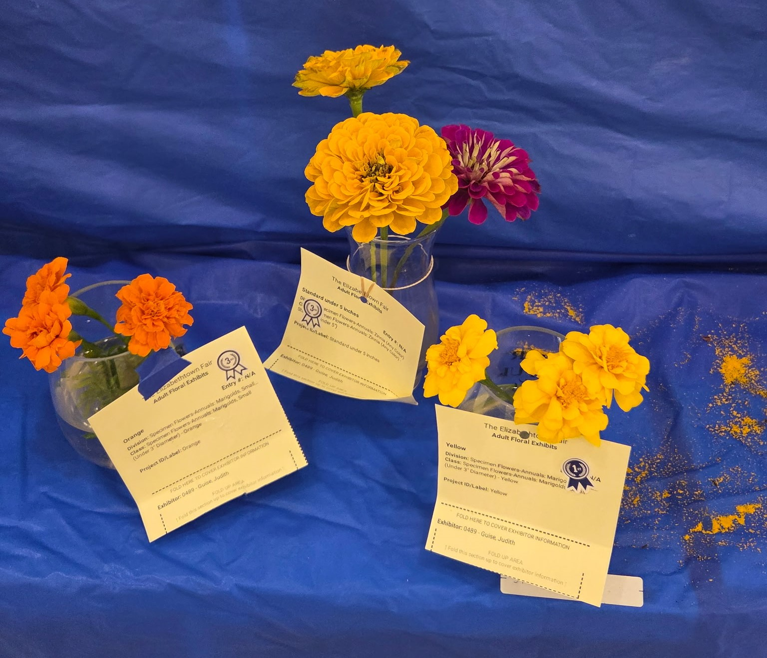

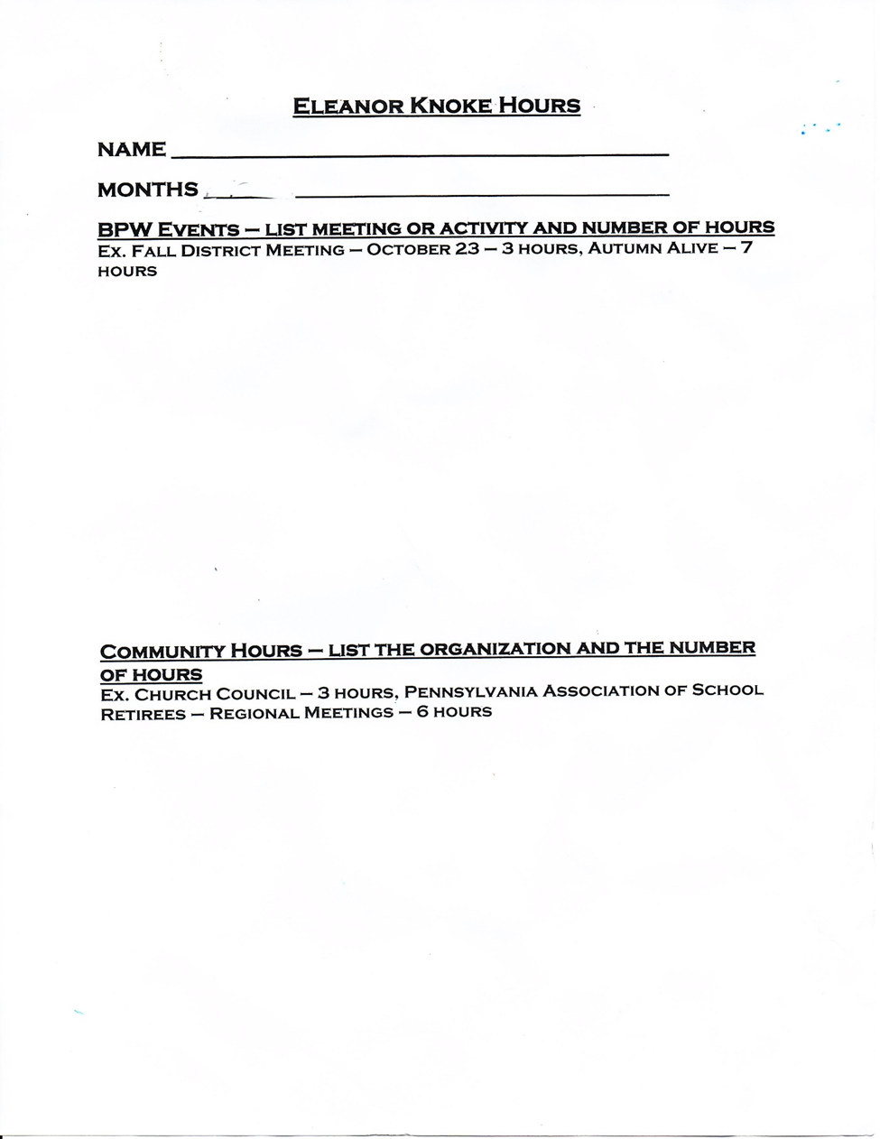

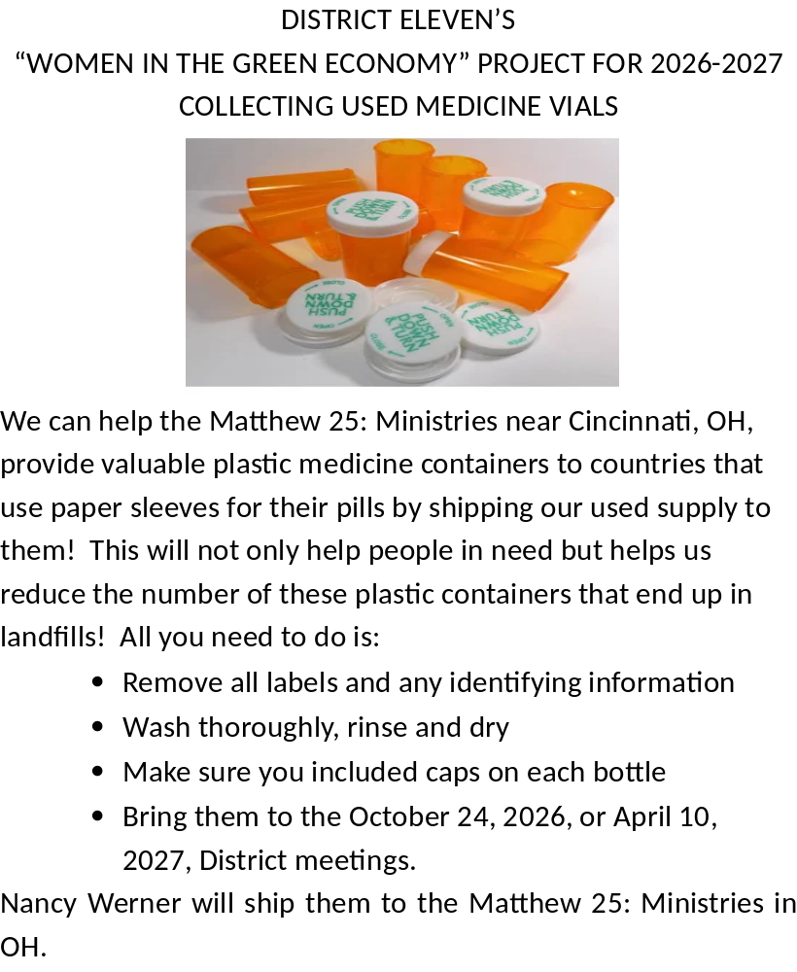

PATRONS

If you wish to be a patron, please give Linda Moskal your business card. Charge for patrons is $10 per year, payable to Quakertown BPW. Proceeds offset printing.
Thanks to our patrons.

2026 -2027 PATRONS

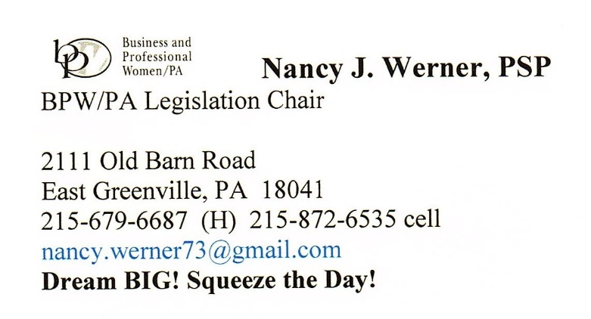 | 
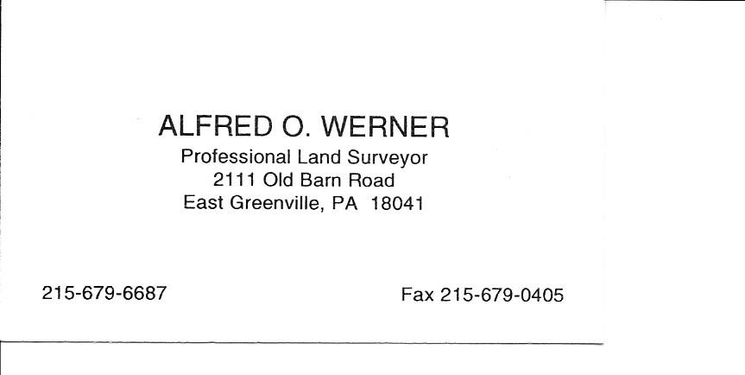 | 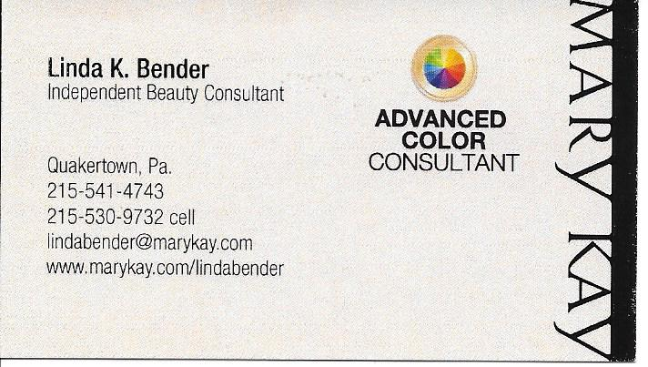
 | 

